CHOI Jang Hyeon (1155077214)

Supervisors: Professors JIA Jiaya and YU Bei

Mentor: Mr. QI Sun

CSE Department

Term 2, 2020-21

March 29th, 2021

FYP Progress Report: Week 12

NHWC with image shape fixed:

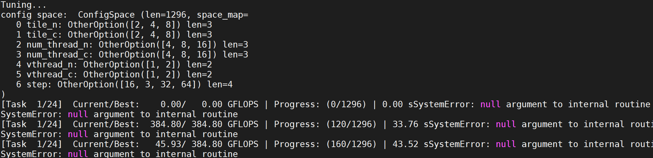

NCHW

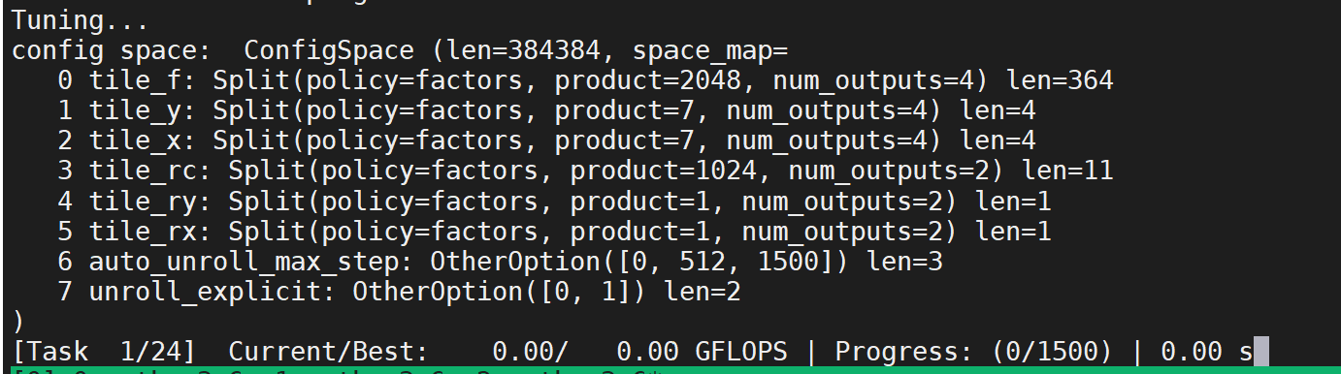

Accelerating the convolution process:

Changing the step did not bring significant improvements in the inference cost.

Changing the num_threads and tiles (=block) only worsened the performance.

NCHW

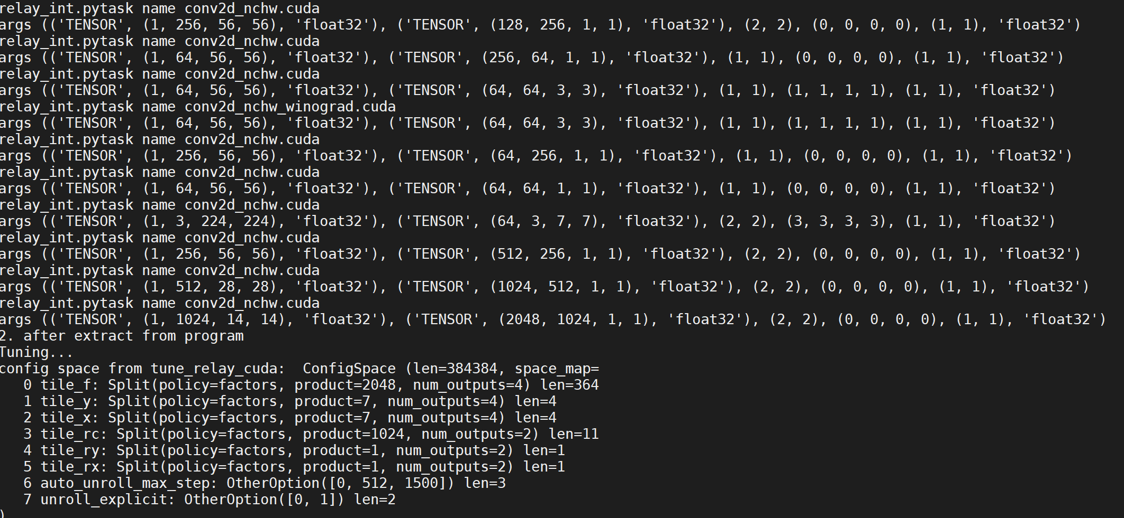

NHWC

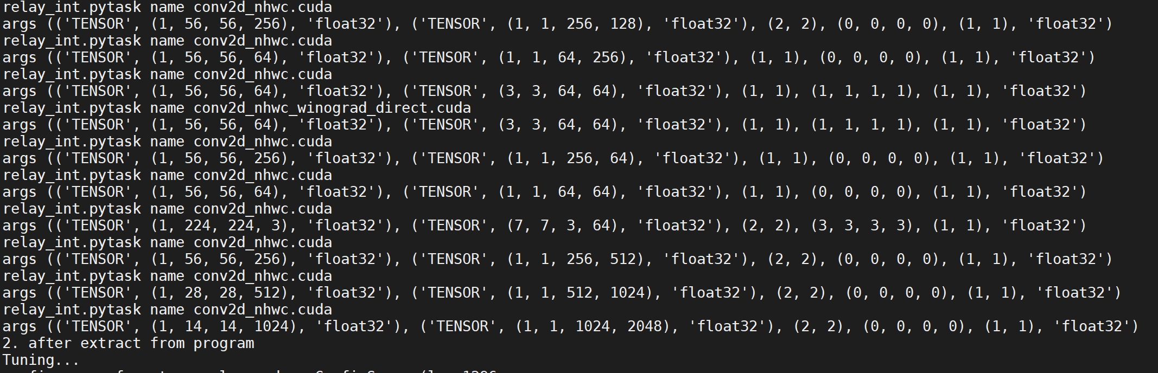

Because the tensor values are tuples, I cannot concatenate tensor values after they have been defined due to their immutable nature. These tensor values are determined by the ‘mod’ and ‘params’ variables which are defined in the early stages of the program, so I need to focus on tinkering with these variables, which are a Function class and a dictionary, respectively.

The format of their feature representations are the same.

Inside shape_dict

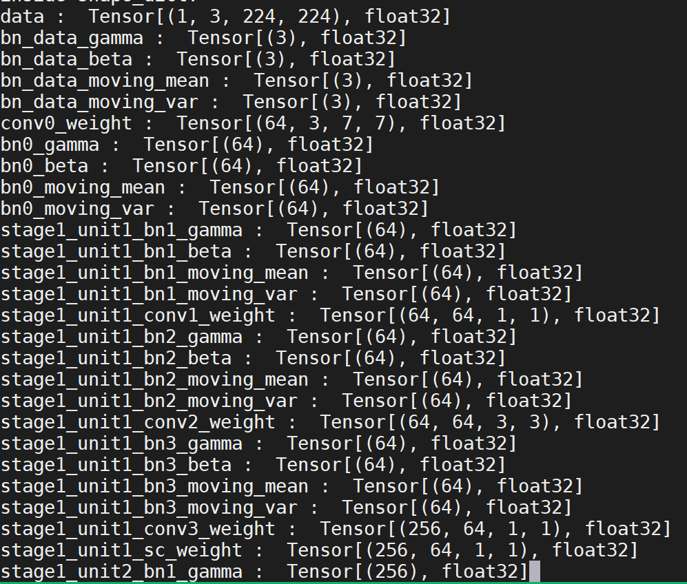

NHWC shape dict

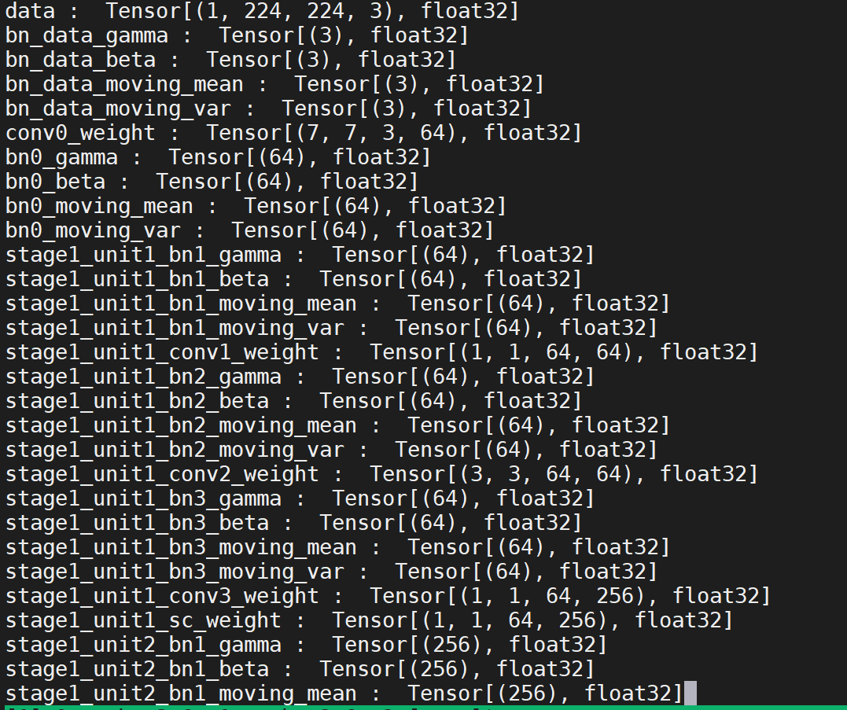

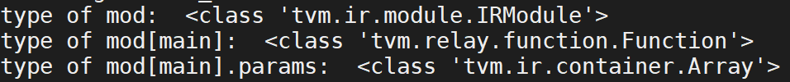

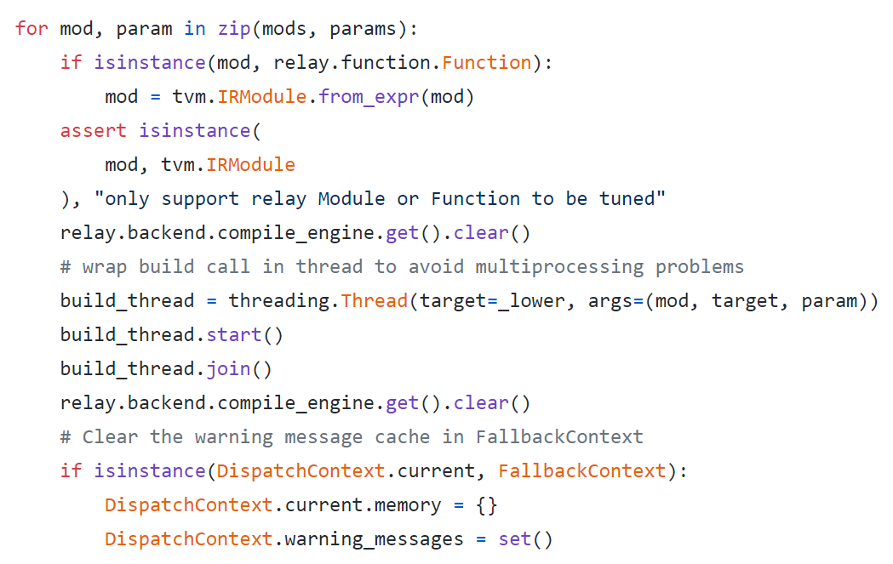

Because of the zip() function, it will only iterate until the shortest index, meaning the recently added parameters are not computed. Thus, I had to insert the parameters into the mods variable as well.

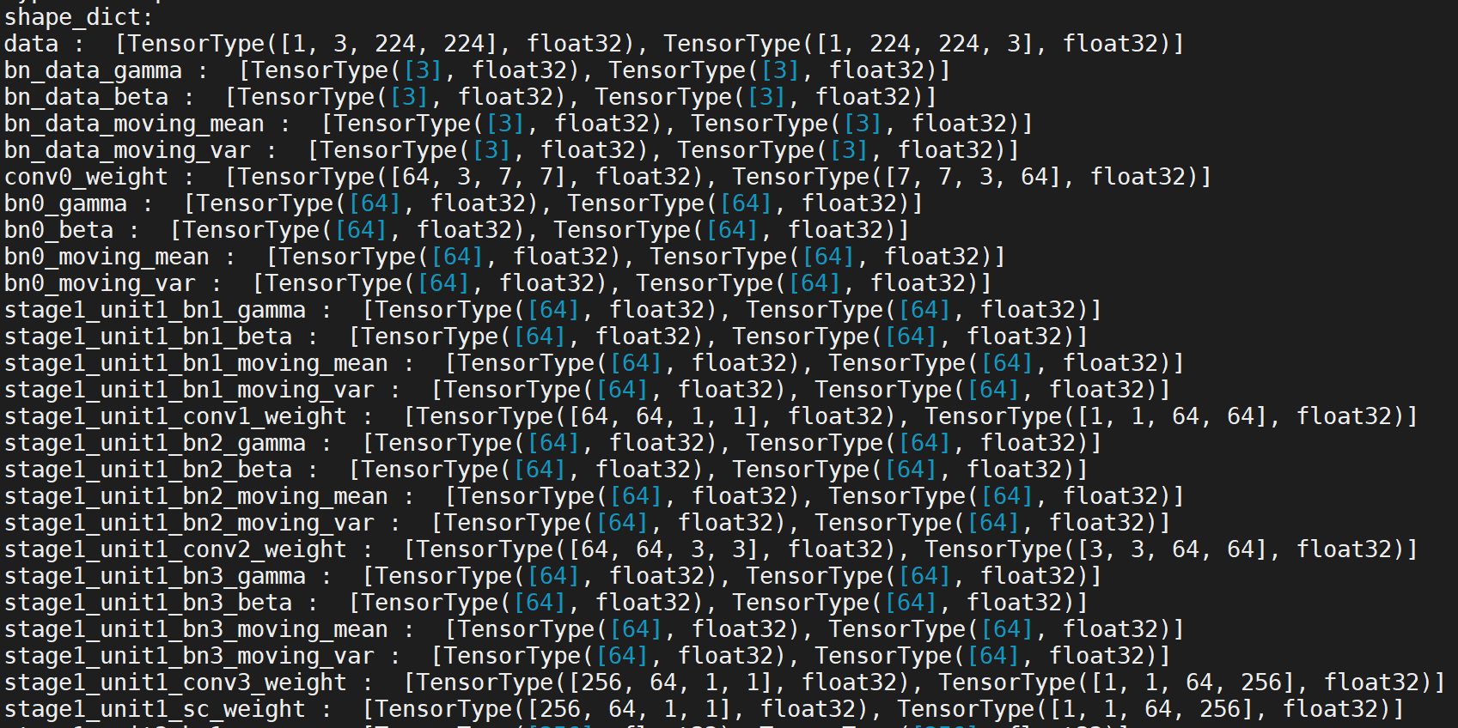

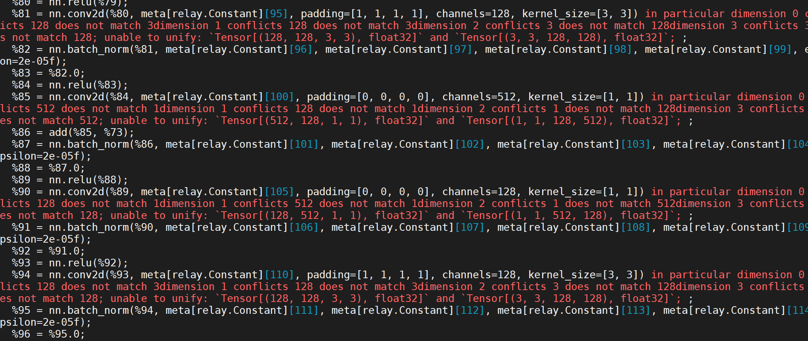

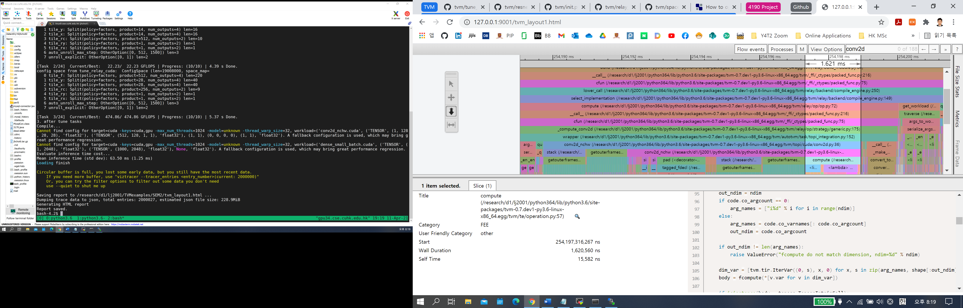

Parameters

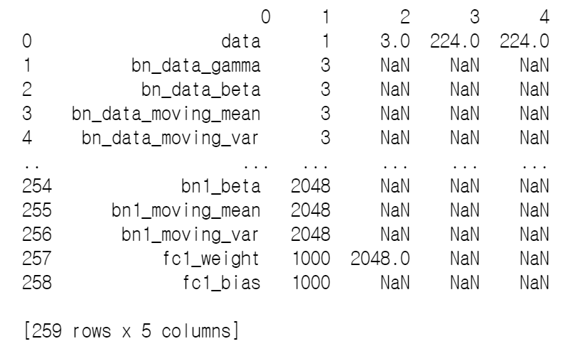

Numbers in first numerical column

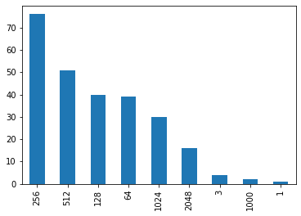

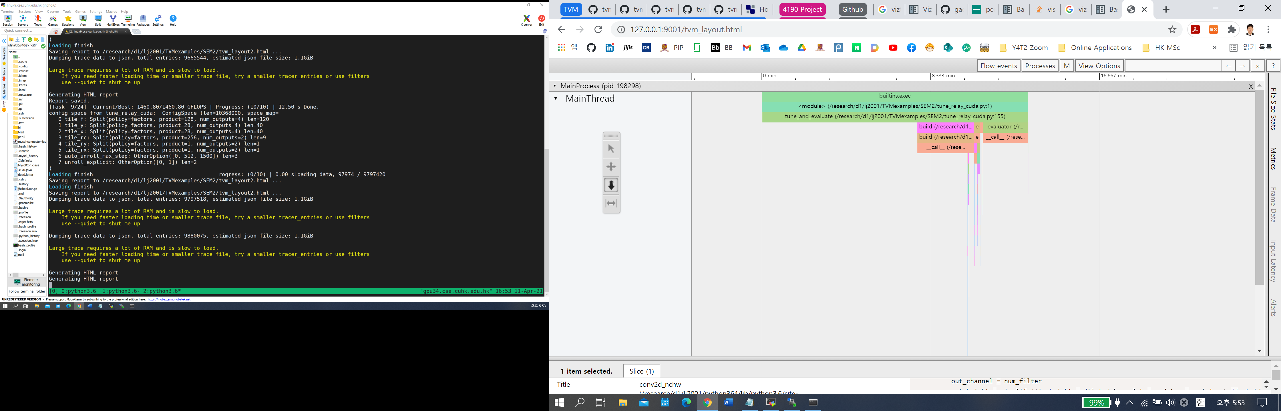  
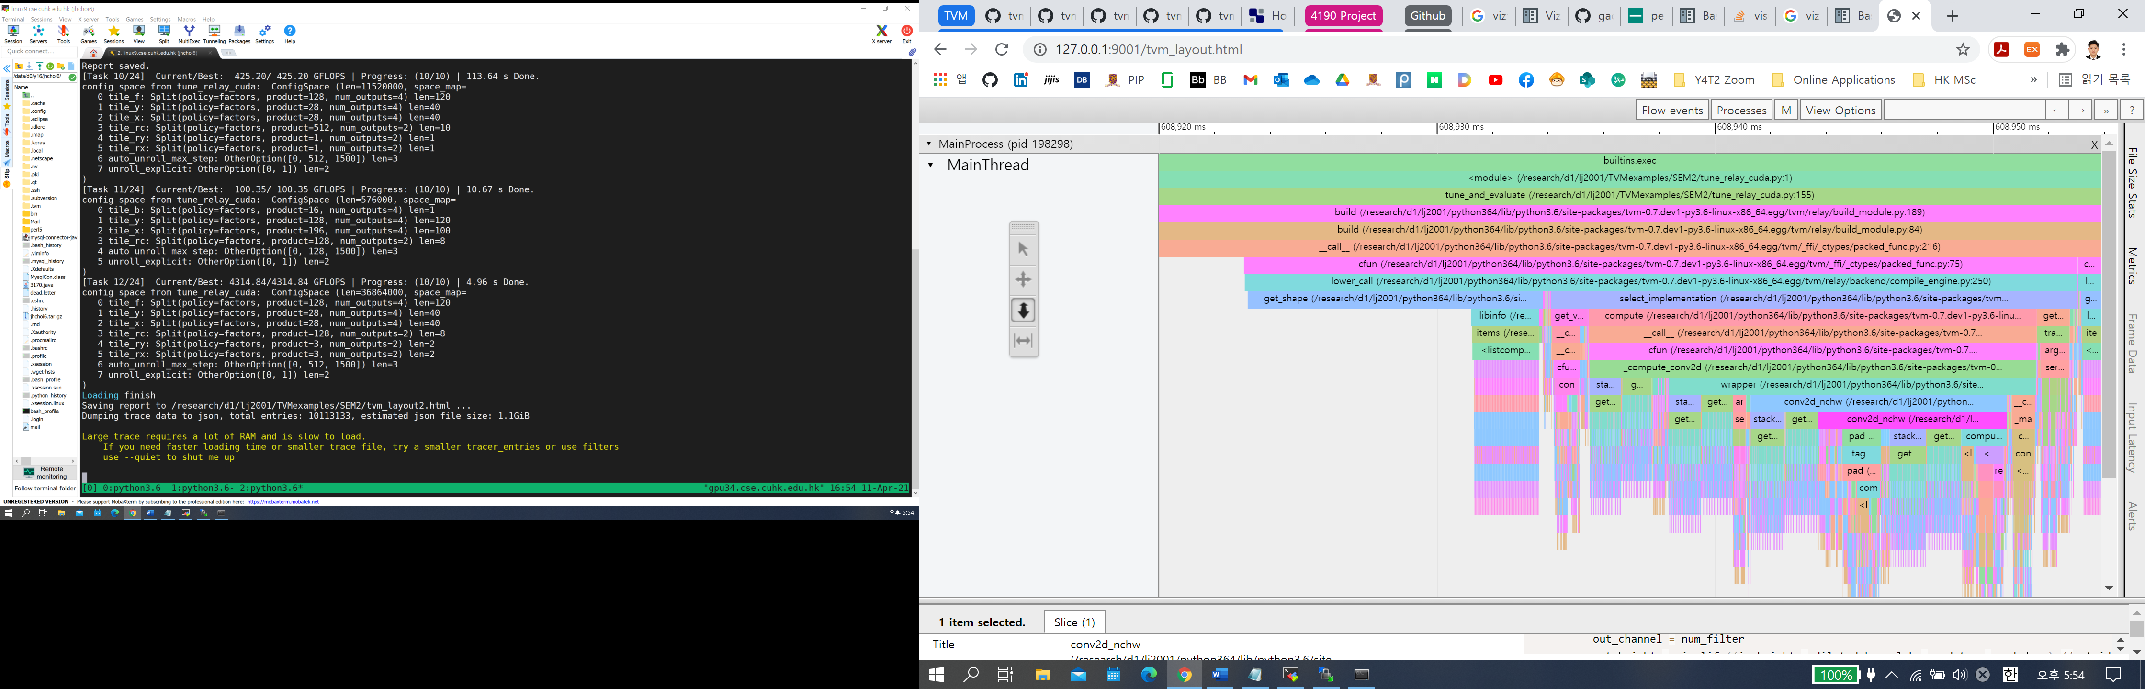

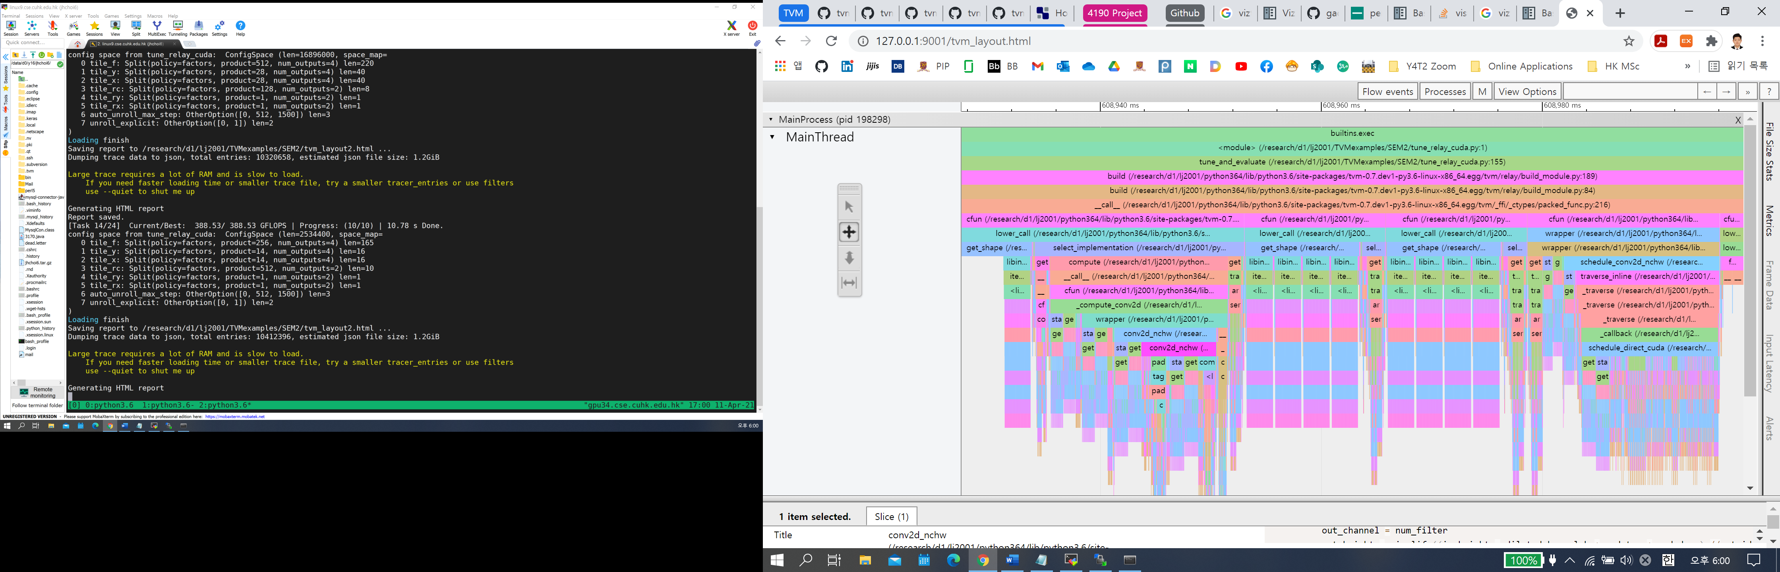

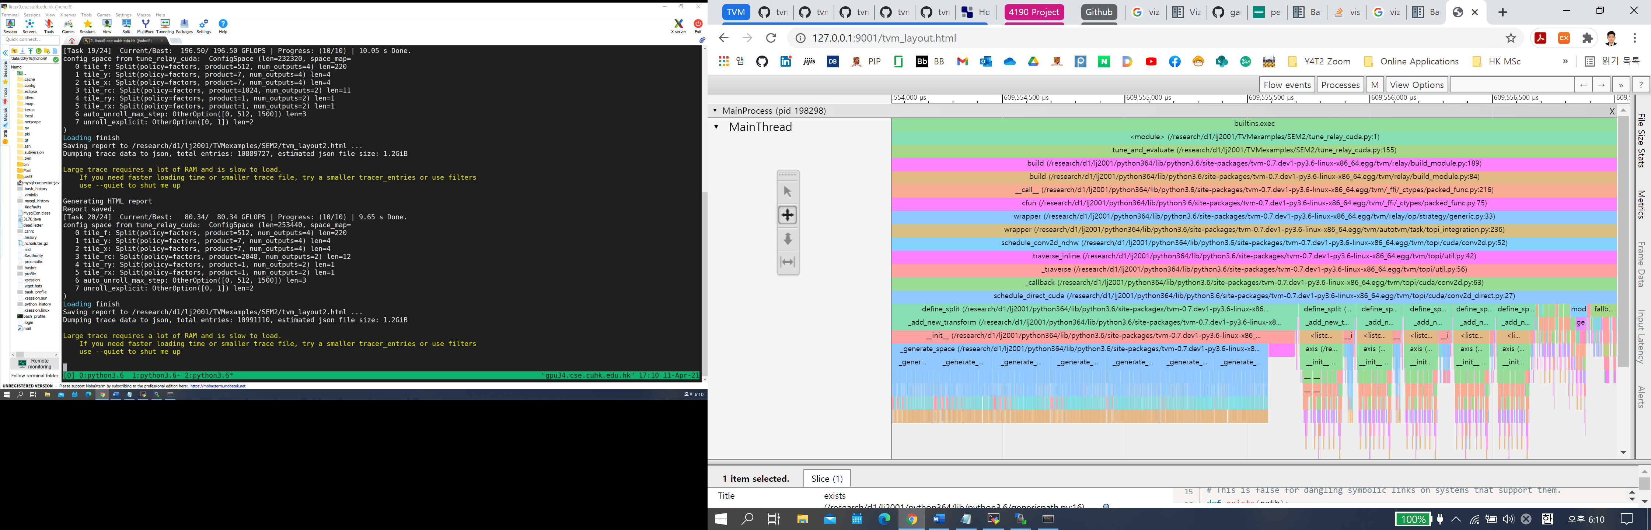

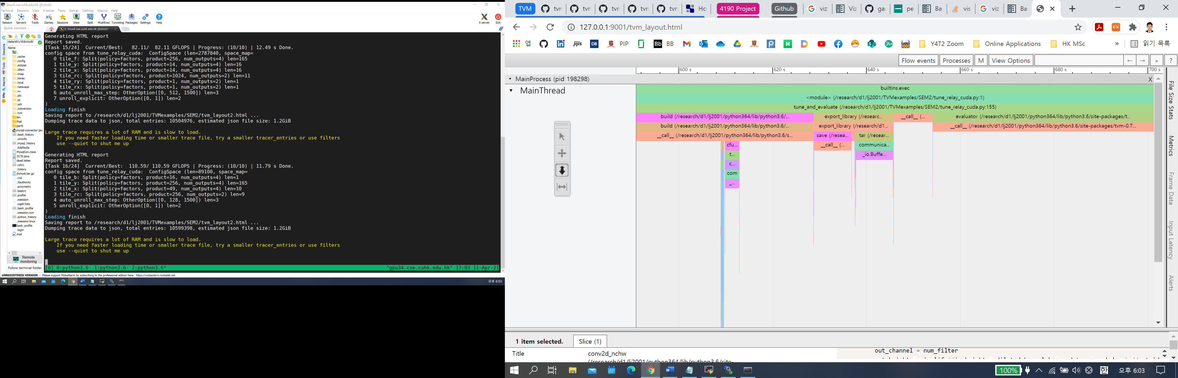

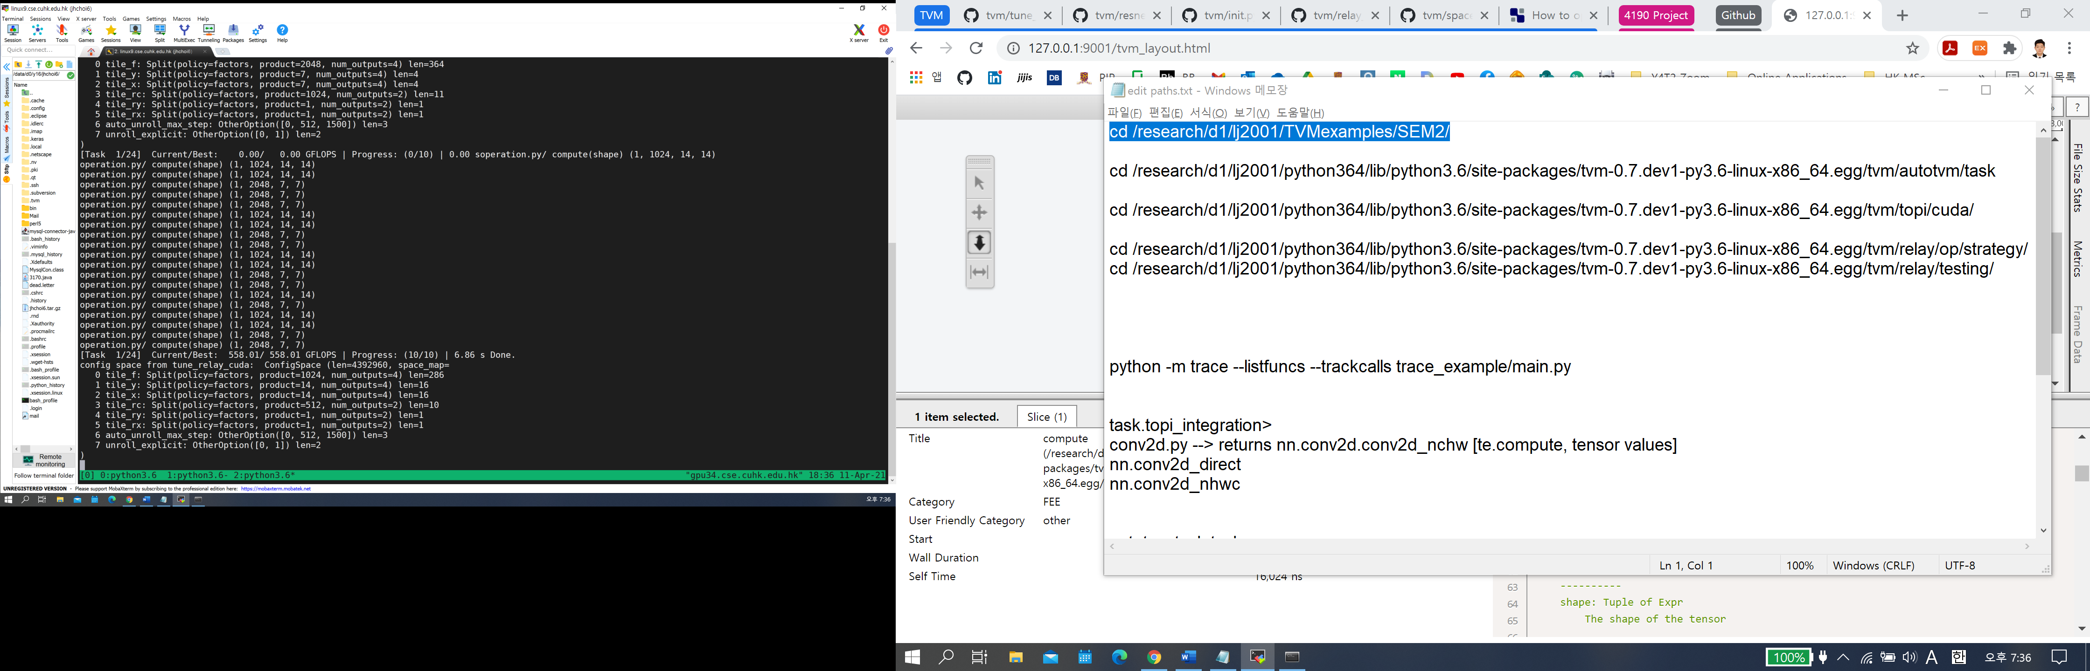

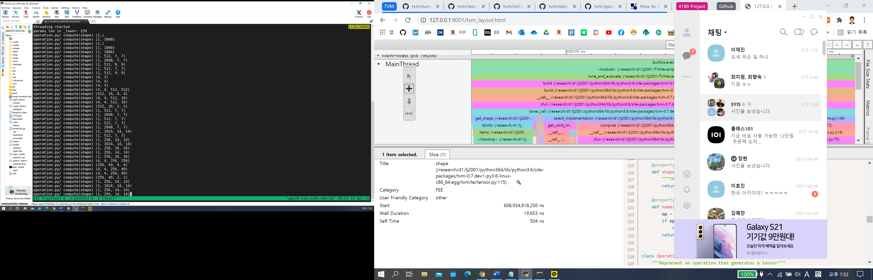

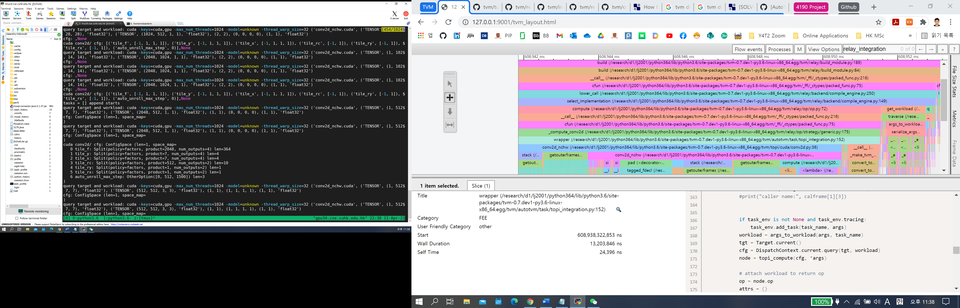

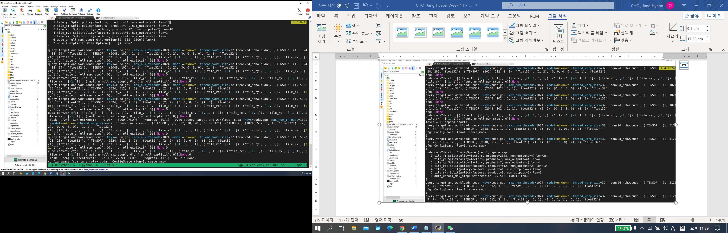

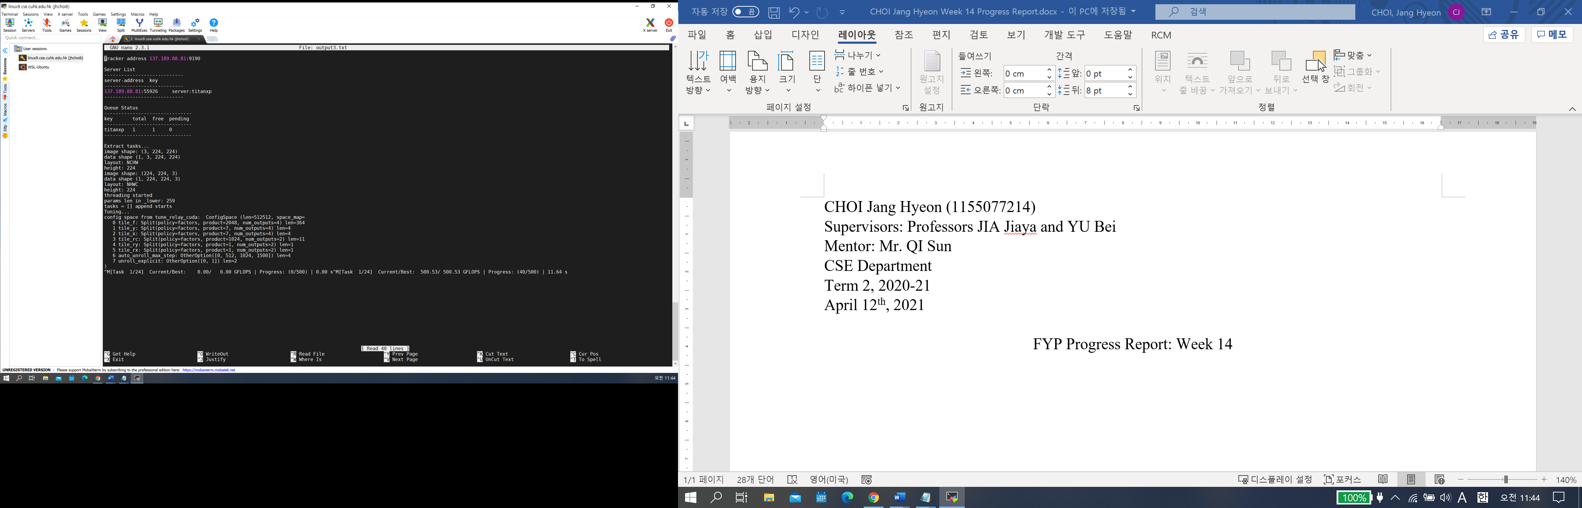

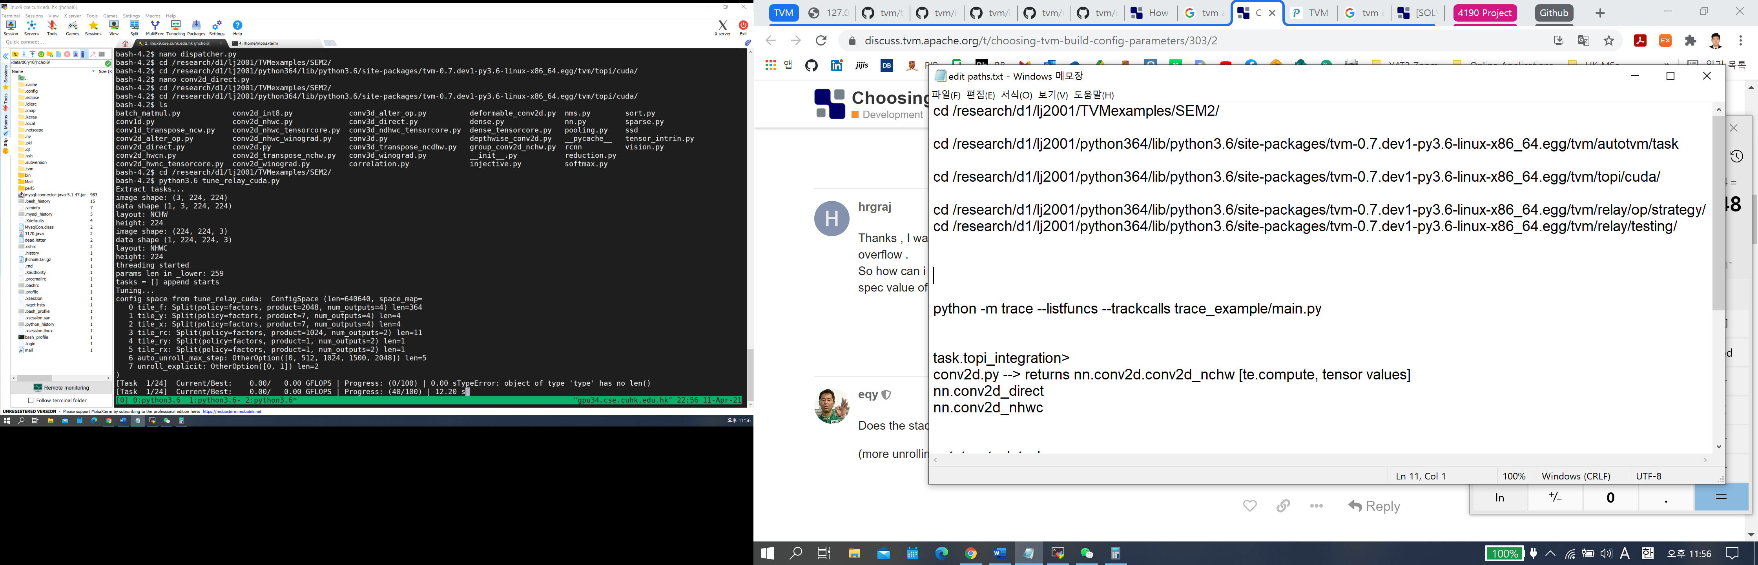

Increase auto_unroll_max_step configuration

From [0, 512, 1500] to [0, 512, 1024, 1500, 2048] to [0, 512, 1024, 1500]

Offset for adding copies or unrolling the loop until the specified threshold